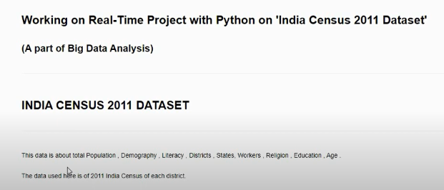



1. How will you hide the indexes of the dataframe.

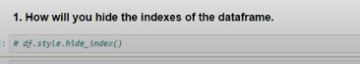

2. How can we set the caption / heading on the dataframe.



3. Show the records related with the districts - New Delhi, Lucknow, Jaipur.

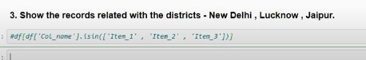

4. Calculate state-wise:

A. Total number of population

B. Total no. of population with different religions

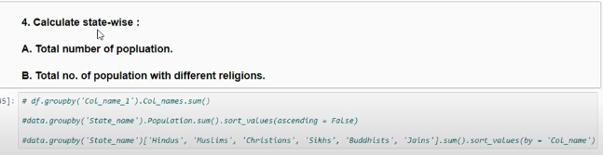

5. How many Male Workers were there in Maharashtra state ?

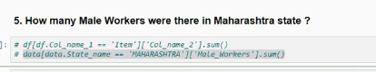

6. How to set a column as index of the dataframe ?

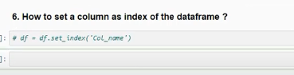

7a. Add a Suffix to the column names.

7b. Add a Prefix to the column names.

